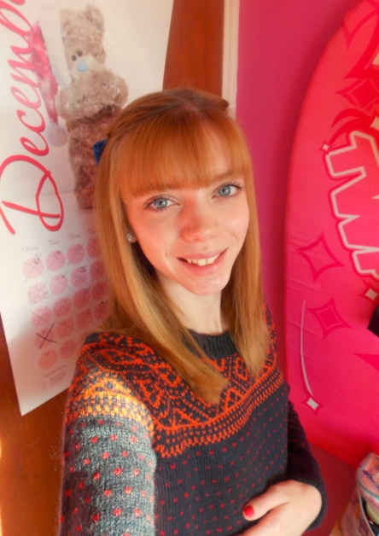
Kelly Page

Personal Statement
I’m 20 years of age and I have a huge passion for animals. My love for them started back in 2008, when I brought my first puppy Sasha and from there I started to progress my career further involving animals. Since then I have studied animals in various topics and completed several weeks at different animal industries to gain as much experience as possible. I am still studying animals currently, completing my foundation degree in animal management and applied science at Sparsholt College which I hope to graduate from in June 2015. I am now looking for a full time career to pursue or voluntary positions to further widen my experience. I do have other strong interests such as running inspired by my dad, which I have been doing since the age of 5. I also love fashion, photography and child care. I currently hold a full UK driving licence.

Education
September 2013 – Present
Foundation Degree in Animal Management and Applied Science at Sparsholt College
September 2010 – June 2012
Extended Diploma in Animal Management at level 3 at Sparsholt College
January 2012 – July 2012
Functional Skills Level 2 in Maths
September 2005 – July 2010
Studied at Crestwood College achieving 12 GCSE’s including 9 GCSE passes: English B, Maths D, and Science CC

Employment History
May 2012 – August 2012
Casual Sales Assistant at Pampurred Pets in Eastleigh
September 2012 – May 2013
Stock Movement Assistant at Debenhams in Winchester
June 2013 – December 2013
Sales Assistant at Moda in Pelle in Winchester
June 2014 – September 2014
Lingerie Sales Advisor at Debenhams in Winchester

February 2014 – December 2014
Stock Movement Assistant at Debenhams in Winchester
September 2014 – Present
Saturday Girl at Cedar Veterinary Group in Alton

Voluntary Experience
Starting in April 2015
Animal Carer at HART Wildlife Rescue in Alton.

Work Experience
2009 – Two weeks at Gleneagles Riding School.
Duties included: Mucking out stables, cleaning tack, grooming, tacking up before lessons, feeding, watering and maintaining the yard.

2011 – Two weeks at Mildmay Veterinary Practice.
Duties included: Assisting with operations, preparing for operations, observing theatre operations, maintaining the surgery and impatient care.

2011 – One week at Gay dog boarding kennel and cattery.
Duties included: Maintaining the kennels, exercising the dogs, allowing the dogs out in the yards, gardening, welcoming customers and observing dog behaviour for pairing.

2012 – Three weeks at Pampurred Pets
Duties included: Stocking shelves, maintaining the shop, re-stocking food bins, serving customers on the till and date checking produce.

2014 – One week at Anton Veterinary Practice
Duties included: Setting up animal enclosures for clients being emitted to the practice, observing operations, maintaining the high hygiene standards of the practice by moping, sweeping, dust washing and wiping down surfaces daily, and sterilising and packing instruments after theatre.

2014 – Two weeks at HART Wildlife Rescue
Duties included: cleaning animal enclosures such as containers and aviaries, complete daily health checks on the wildlife, maintain the centres hygiene standards by sweeping and moping daily, examining faeces samples under the microscope to identify any parasites and provide the wildlife with the nutritional requirements that they need.
2015 – Three weeks at Top Dog Canine Hydrotherapy.
Duties included: Introducing clients to the clinic, pre and post session showering, controlling the underwater treadmill settings for each client, assisting with support for the client, exercising clients within the hydrotherapy pool, accessing the gait and injuries of the client during the session, undertaking cleaning requirements of the pool such as hovering and watermarks, the underwater treadmill such as grease marks and removal of hair and the floor such as hosing down mud and hair.

Interests
Animals – Animals are my ultimate passion as I love caring and looking after my own at home. I currently have two dogs, four budgies and eight giant African snails. I love studying animals and enjoy every chance I get when I work with them.
Sport – Going out for a run keeps me fit and healthy and also requires dedications after doing it for 15 years. I also love to compete in races mainly on road and I have been a previous member of Winchester running club juniors and Eastleigh running club.
Music – Listening to music is a great way of relaxing. I play the clarinet as a hobby and I also have a keen interest in playing the drums. I also like to go to watch bands at gigs and festivals such as the Isle of Wight festival.
Socialising – I am very family orientated. Spending time with my family and loved ones is very important to me.

References

