Contents
Placement Details 2
Aims and Objectives 2
Description of Product/Service 2
Placement Description 3
Physical Resources 3
Human Resources 4
Operational regime 5
Site Management 5
Husbandry Practice 5
Production Methods 5
Strengths and Weaknesses 5
Work Placement in Industry 6
Placement Analysis 7
References 7

Work Experience at Top Dog Canine Hydrotherapy

Placement Details
Below are the basic details of my work experience placement including the name of the business, address, contact telephone number, email address and website link.
- The full name of the business is Top Dog Canine Hydrotherapy.
- The address of top dog; Harroway Farmhouse, Penton Mewsey, Andover, Hampshire, SP11 0QZ.
- Telephone contact number for top dog; 01264 771824.
- Email address of top dog; enquiries@topdoghydrotherapy.com.
- Website link for top dogs website; http://topdoghydrotherapy.com/wp/ (Top Dog Hydrotherapy, 2013)

Aims and Objectives
Top dog hydrotherapy has one main overall aim that they repeat in their establishment and on their website which is; to improve or maintain your pet’s quality of life (Top Dog Hydrotherapy, 2013). During the different sessions, there are other personal more unique aims for the individual client. For example, does the employee want to aim for an improvement in the session or does the employee want to see if the client can work for an extra minute.

Description of Product/Service
Mainly this business offers a service rather than a product as they provide either a half an hour or an hour hydrotherapy session for dog’s who either need rehabilitation therapy for example, after an operation for a skeletal injury (Top Dog Hydrotherapy, 2013). Or sessions can be for general health and fitness of the canine’s body. Within the reception of top dog, they sell various products relating to the service they provide. They sell food related products such as tubes of liver paste. These are mainly encouraged for clients who have sessions on the underwater treadmill to help tempt them to walk straight throughout the session. Top dog also sell various branded vitamin supplements, mainly for canine joints, which is a condition often seen being treated with hydrotherapy (McGowan, et al., 2007).

Placement Description
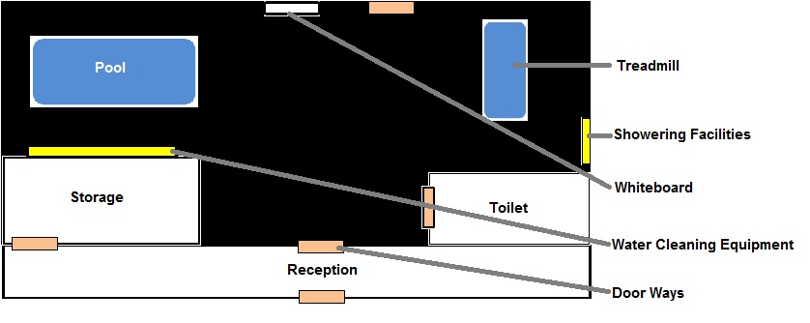
Plate 1: Basic layout of the Andover branch (Authors Own, 2015)
The Andover branch of top dog is actually smaller when compared to the Newbury branch. The Andover branch comprises of a hydrotherapy pool and underwater treadmill that is offered to the clients for their treatment. There is an open reception when entering the establishment which includes a seating area, a fish tank and a desk where the employee’s work from when not with clients. On the left is the storage room where there is tea and coffee making facilities. This is also where all the clients’ paperwork is kept organised into filing cabinets. On the right, are the toilet facilities for the employee’s. When entering the main part of the building, straight ahead is the whiteboard which has the clients for the current day, details ready for the session. On the right is the showering facility which includes a blow-dryer. The harnesses’s and float coats for the clients are also stored here. Lastly, on the left next to the pool is the water cleaning equipment including the pool hover and hair sieve.

Physical Resources
Being a small company, top dog does not have many physical resources. The main two physical resources they have is the hydrotherapy pool and underwater treadmill as these are both used everyday numerous times. Without these, top dog cannot offer their hydrotherapy services to their clients. Specifically in this business, the underwater treadmill is used more often than the pool. If either of the equipment has maintenance work undertaken on it then top dog would not take any clients meaning they lose out on a day’s work. This shows how essential these two resources are to the company. Two other physical resources which are used in everyday work at top dog are the laptop and the telephone. These are used for arranging appointments, organising events, editing their website and contacting other necessary parties such as veterinary practices.
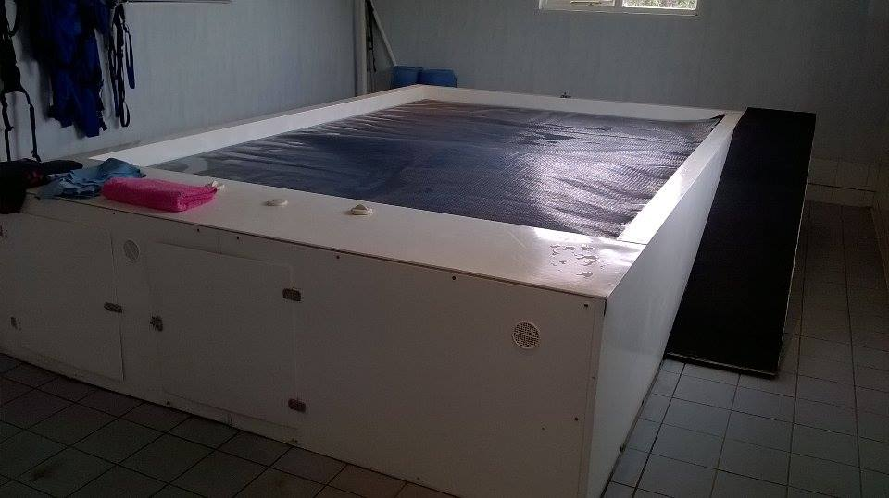
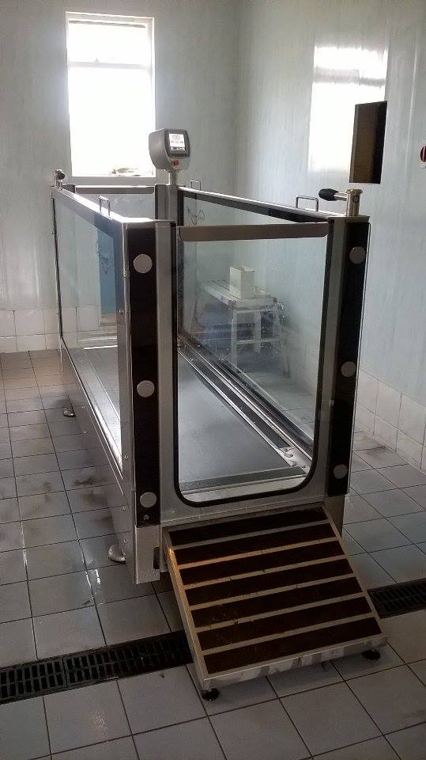

Plate 2 (Above): The hydrotherapy pool used for client sessions at Top dog canine hydrotherapy (Authors Own, 2015).
Plate 3 (Right): The hydrotherapy underwater treadmill used for client sessions at Top dog canine hydrotherapy (Authors Own, 2015).

Human Resources
Below is the hierarchy of workers who work at the Andover branch of Top dog canine hydrotherapy.
Maggie is a qualified hydrotherapist and has always wanted to open her own hydrotherapy business. Maggie currently works two days a week but always looks in when needed.

Maggie Cunniffe (founder)

Zara joined the company after completing work experience and became a qualified hydrotherapist. Zara currently works four days a week.
Zara Toms (full time hydrotherapist)

Linda is a retired teacher and because of her love for dogs became a qualified hydrotherapist. Linda currently works every Saturday.
Ellie Townley (part time help)
Linda Salmon (part time hydrotherapist)

Ellie joined the company after completing work experience. After her course she hopes to become a qualified hydrotherapist and join full time. Ellie currently works two days and two evenings a week.

Operational regime

Site Management
Top dog is open five days a week, Tuesday through to Saturday, with somebody managing the site area every day. As each employee that works at top dog is not there every day for the five days, it is someone different in charge every day. On a typical working week, Zara is in charge on Tuesdays and Thursdays, Maggie is in charge on Wednesdays and Fridays and Linda is in charge on Saturdays. As site manager, they are responsible for the smooth running of the business, making sure the clients are comfortable during their session and ensuring the client’s owners are happy with their dog’s progress.

Husbandry Practice
Due to the nature of the industry there is minimal husbandry practice when compared to other industries such as veterinary practices or kennels. However, there is still important husbandry practice involved as the client’s health is the number one priority when it comes to hydrotherapy. Consideration needs to be taken when thinking about handling the dog’s when helping them in and out the pool or the treadmill as they may have injuries to their hips or cruciates. Ensuring that they make it safely through the door, their session and back out is the most important husbandry practice for this particular company.

Production Methods
Before a client arrives for their session, everything needs to be prepared and ready which helps with a smooth production method. Tog dog’s production methods are slightly different for the treadmill and the pool. Both methods are the same to begin with as illustrated below;
- Firstly the client and their owner are welcomed on arrival.
- The client is then showered and provided with the correct equipment.
- The client is either assisted into the treadmill or the pool depending on their session. The session then takes place.
- This next step is where the two methods differ. If the treadmill is used than one employee takes the client and gets them showered and dried. The other cleans the grease mark around the glass of the treadmill ready for the next client. With pool sessions this is not necessary. Instead the other employee sieves the pool for hair and then covers the pool to keep it heated.
- The owner is then offered another follow up session and bookings are taken.

Strengths and Weaknesses
Every business has strong points and weaker points where improvements can always be made. Top dogs strengths included; customer communication, employee knowledge and organisation of paperwork. The business weaknesses included; employee communication, business advertising and considering work load.
- Having a business that highly includes face to face communication needs to be handled correctly and professionally (Hinds, et al., 2002). Having good customer relations helps for a continue flow in business and gives the customer the satisfaction of the service or product.
- When looking for a particular problem in a situation, the employee needs to know what to look for. Good knowledge and training for the job is essential for the client to receive the correct treatment (Eraut, 2000). Top dogs employees have good knowledge and could easily discuss with owners what the problem was.
- Top dog organise each of their clients paper work into individual folders, making notes about every session each client has, to ensure all employees are up to date. Having an organised system in a business involving paperwork is essential for the smooth running of the day’s operational routine (Pollock, et al., 2004).
- Although the communication between employee and customer were of a high standard, the communication between employees was not so clear. If a team of two employees were working together, in some sessions each employee would be un-sure about what job role they should be doing.
- Top dog has their own website which is one of their main advertising resources. However, some of the information on the website is out dated. Several clients commented on this during their dog’s session. This could give clients a bad impression of the business.
- Currently as a growing business, top dog has a growing client base. However, on some working days, sessions ended up going over their time leaving less time for the sessions at the end of the day.

Work Placement in Industry
Attending an educational course is beneficial when a student wants to progress into a particular career (Yildirim, 2000). Gaining the basic knowledge in topics which are involved within the students chosen career path does not provide the experiences which working in the industry would (Crebert, et al., 2004). Hydrotherapy in particular is not something which is taught unless a specific canine hydrotherapy course is under taken. Involved in these courses would allow the student to learn about the business but would not allow these skills to be developed physically (Hawksmoor, 2014). Having the chance to complete a placement gives the student the chance to handle clients, use the equipment and learn the operational routine from the employers.
Not only does it allow students to develop these skills, work placement also improves employment prospects either by putting it on a CV or being recognised on placement and being offered a job role (Billett, 2001).

Placement Analysis
While on work placement, an employer questionnaire was provided to the employer, as preparation for a one to one interview between student and employer. In the questionnaire, ten questions were provided. Areas covered included;
- Whether there have been any changes to this particular business and the industry on a whole within the last five years.
- If there are any more changes planned for the business over the next five years.
- Whether the business is changing and in what ways.
- If the owner is happy with the progress of the business since opening.
- If the owner could have done anything differently to the business since opening that would have been changed.
- Lastly, five questions about the owner of the business including interests, training and personal opinions.
The layout of the questionnaire was a basic question and answer. First the question with keywords highlighted in bold and then a space for both the employer’s answers and the students notes. This basic layout allows both parties to discuss the questions in more detail before writing anything down.
The questions asked are based around what is happening to the business and the industry. This is to give the student some idea of how the business has developed since first opening to the current day. The questions also ask what is planned for the business in the future to give a better picture of how the business may look in several years time. Lastly, discussing the industry on the whole gives the student a better insight into why this specific industry is relevant to animal management.
1096 words (Operational routine and placement analysis).

References
Billett, S., 2001. Learning through work: workplace affordances and individual engagement. Journal of Workplace Learning, 13(5), pp. 209-214.
Crebert, G. et al., 2004. Developing generic skills at university, during work placement and in employment: graduates' perceptions. Higher Education Research & Development, 23(2), pp. 147-165.
Eraut, M., 2000. Non-formal learning and tacit knowledge in professional work. British Journal of Educational Psychology, 70(1), pp. 113-136.
Hawksmoor, 2014. Level 3 Certificate in Hydrotherapy for Small Animals. [Online]
Available at: http://www.hawksmoorhydrotherapy.com/hawksmoor-training-centre/accredited-abc-courses/level-3-certificate-in-hydrotherapy-for-small-animals/
[Accessed 2015].
Hinds, P. J. & Kiesler, S., 2002. The Place of Face to Face Communication in Distrubuted Work. In: Distributed Work. Massachusetts: Massachusetts Institute of Technology, pp. 83-97.
McGowan, M. C., Goff, L. & Stubbs, N., 2007. Animal Physiotherapy: Assessment, Treatment and Rehabilitation of Animals. Oxford: Blackwell Publishing.
Pollock, N. & Cornford, J., 2004. ERP systems and the university as a “unique” organisation. Information Technology & People, 17(1), pp. 31-52.
Top Dog Hydrotherapy, 2013. Benefits. [Online]
Available at: http://topdoghydrotherapy.com/wp/?page_id=11
[Accessed 2015].
Top Dog Hydrotherapy, 2013. Contact Us. [Online]
Available at: http://topdoghydrotherapy.com/wp/?page_id=34
[Accessed 2015].
Top Dog Hydrotherapy, 2013. Home. [Online]
Available at: http://topdoghydrotherapy.com/wp/
[Accessed 2015].
Yildirim, S., 2000. Effects of an Educational Computing Course on Preservice and Inservice Teachers. Journal of Research on Computing in Education, 32(4), pp. 479-495.

