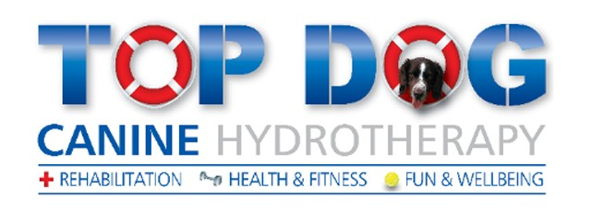
Plate 1: (Top Dog Canine Hydrotherapy, 2015)
Definition of canine hydrotherapy: Canine hydrotherapy is a form of hydrotherapy directed at the treatment of chronic conditions, post-operative recovery and pre-operative or general fitness in dogs (Canine Hydrotherapy Association, 2014).

About Top Dog
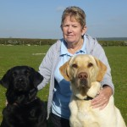
Top dog hydrotherapy was founded by a lady called Maggie Cunniffe, opening up the little Andover branch in her own back garden in 2007. Maggie is a kennel club breeder and has bred her own Labradors for many years. Maggie is qualified in all aspects of canine hydrotherapy and is well respected by many of her referral vets. After the success of her business she then opened up another branch in Newbury. Top dog has always aimed to achieve goals for their clients with their main one being ‘to improve or maintain your pet’s quality of life.’ They are a member of the canine hydrotherapy association and work with many veterinary establishments throughout southern England. Joining Maggie, there are 3 other qualified hydrotherapists who are Zara, Louise and Linda. They offer their clients the use of a small pool or a water treadmill, depending on the dog’s reasons for having hydrotherapy, charging £40 per session (Top Dog Canine Hydrotherpy, 2015).
Plate 2: (Top Dog Canine Hydrotherapy, 2015)

My Targets
1. Learn at least 3 conditions that hydrotherapy can be referred to as a treatment.
2. Be able to fully work independently the water treadmill with a variety of different clients.
3. Learn the process of introducing a client to the hydrotherapy pool and monitor their session with a member of staff.
4. Be able to establish the different equipment involved with canine hydrotherapy.
5. Become more comfortable and confident handling clients in front of their owners over the three week period.
6. Become familiar with the advertising process that Top Dog undertake including veterinary practices, newspaper clips and the internet.

First Year Placement
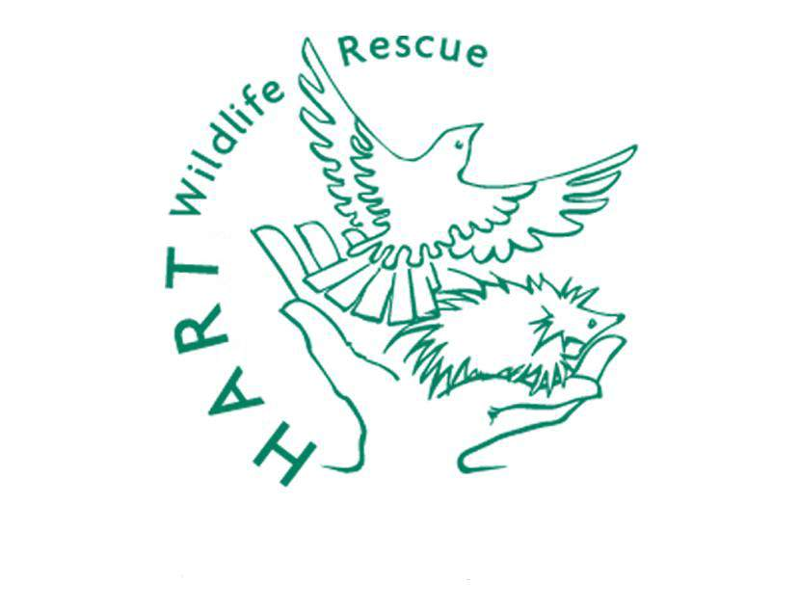
My first year placements included HART wildlife and Anton vets. Both these placements influenced my choice for my second year placement based on the following points:
Plate 3: (Hart Wildlife, 2010)
- I would rather work with domesticated animals or ‘pet’ animals preferably dogs or birds.
- I love working in smaller businesses as to me it feels like a more familiar, friendly and family like environment.
- I have done various placements in different veterinary establishments and wanted to try something different to widen my knowledge and experiences.
- I am keen to keep on learning about an animal’s health in particular companion animals such as breed specific diseases and how they can be treated.
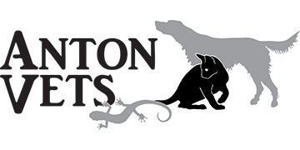
- Finding these previous placements, I had to look further from home which is what I have continued to do to find industries that I would like to work in.
- I want to gain more experience with face to face customer contact which I didn’t have at tall in my first year experiences.
- I have seen previously, hydrotherapists working with dogs in a purpose built hydrotherapy pool in practice which introduced me to idea of canine hydrotherapy.
Plate 4: (Anton Vets, 2014)

The Future
Applying this placement to my future gives me the possible following outcomes:
- If I enjoy my placement, I could continue at Top dog and do on the job training to become a qualified hydrotherapist. After becoming qualified I could work as a full time hydrotherapist at Top dog or another hydrotherapy establishment.
- If I do not get this offer, paying to start a course on canine hydrotherapy for several weeks can also be done to allow me to become a qualified hydrotherapist (White House Training Ltd, 2015).
- If I do not want to continue with canine hydrotherapy, veterinary nursing is my second option and I could take the knowledge I have gained and apply it to any further training.
- If I would like both canine hydrotherapy and veterinary nursing, working as a hydrotherapist in a hydrotherapy unit, established within a veterinary practice is a possible option.

References
Anton Vets. (2014). Welcome to Anton Vets. Retrieved from Anton Vets: http://antonvets.co.uk/
Canine Hydrotherapy Association. (2014). Home. Retrieved from Canine Hydrotherapy Association: http://www.canine-hydrotherapy.org/
Hart Wildlife. (2010). About Hart. Retrieved from Hart Wildlife Rescue: http://www.hartwildlife.org.uk/
Top Dog Canine Hydrotherpy. (2015). Home. Retrieved from Top Dog Canine Hydrotherpy: http://topdoghydrotherapy.com/
White House Training Ltd. (2015). Canine Hydrotherapy Training Courses. Retrieved from White House Training: http://www.caninehydrotherapytraining.co.uk/canine-hydrotherapy-training-courses.htm

