Office 13
How to add a video into a Word Document
Go to www.youtube.com
Find a suitable video. You need the embedding code so click on share (a), embed (b) and copy the embedding code (c).
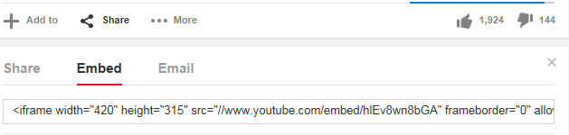
a
b
c


Open your Word document
Click into the insert tab
Click Online Video
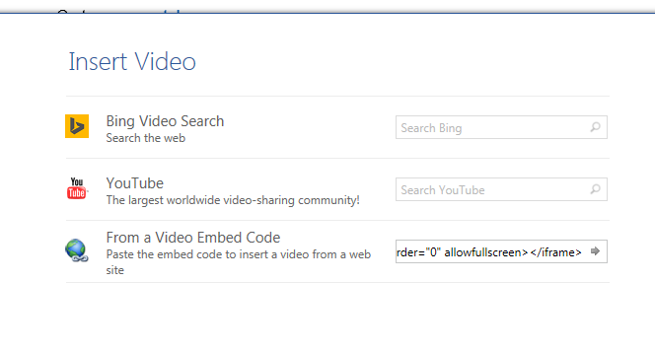
Paste the embedding code and click on the arrow

To exit the video click on this icon and press escape on the keyboard.
